Sponsorship & Tradeshow Booth

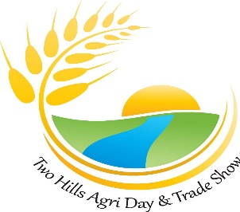
Two Hills Agri Day
Country Market
April 18, 2026
Country life… unlocking our best kept secrets!

Country Market Table Application
Business or Organization: ______________________________
Contact: ____________________________________________
Address:__________________ Town/City:_______________ Postal Code: _______
Phone: ___________________ Cell: _____________________
Email: _____________________________________
Country Market Table
☐ 6 x 6: $30

Please submit your application, email to thagsoc@telusplanet.net
All application deadlines will be March 28, 2026 Please make payment to;
Two Hills Agricultural Society, Box 117, Two Hills, AB, T0B 4K0 or send etransfer to thagsoc@telusplanet.net

